
Control system requirements for the MYRRHA injector Solid-State Amplifiers
MYRRHA (Multi-Purpose hYbrid Research Reactor for High-tech Applications)

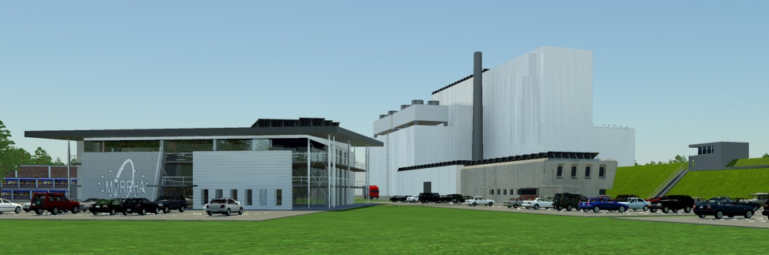

05 February 2019

BEPERKTE VERSPREIDING - NUC / DIFFUSION RESTREINTE - NUC
(Wet van 15 april 1994 / Loi du 15 avril 1994)

Note: English translations are for information only. All legal background of this information is based on the Dutch text.
- Dit document is gecategoriseerd als "BEPERKTE VERSPREIDING - NUC" (Wet van 15 April 1994).
Het document bevat beschrijvingen van uitrustingen, systemen, voorzieningen en andere elementen die zich mogelijk in de vitale zone van een nog niet bestaande nucleaire installatie zullen bevinden en die beveiligd zullen dienen te worden tegen sabotage. Gebaseerd op koninklijk besluit betreffende de categorisering en de bescherming van nucleaire documenten van 17 oktober 2011, art. 2 §3 b) ' wordt de veiligheidsrang « BEPERKTE VERSPREIDING - NUC » toegekend aan de nucleaire documenten die betrekking hebben op …uitrustingen, systemen, voorzieningen of om het even welke andere elementen die zich in de vitale zone bevinden en beveiligd zijn tegen sabotage.

This document is classified as "BEPERKTE VERSPREIDING - NUC" ("RESTRICTED DISTRIBUTION - NUC") according to the Belgian Law of 15 April 1994.
This document contains descriptions of system, structures, components and other elements which may be positioned in vital zones of a not yet existing nuclear installation and will need to be protected from sabotage. Based on the royal decree concerning the categorization and protection of nuclear related documents, dated the 17 October 2011 (art. 2 §3 b) the security classification of « BEPERKTE VERSPREIDING - NUC » ( « RESTRICTED DISTRIBUTION - NUC » ) is assigned to documents that relate to systems, structures, components or other elements that are located in vital zones and are protected against sabotage.
Distributie: | zie tabel p. 4.
Overheid van oorsprong: | auteurs, goedkeurders en hiërarchisch verantwoordelijken zoals vermeld in tabel op p. 4  Voor elke verdere verspreiding van het document moet de 'Need to Know' vastgesteld en gemeld worden aan de Afgevaardigde van de Fysieke Beveiliging van de organisatie
Bewaring van document: | De bestanden van de digitale versies van dit document moeten geëncrypteerd blijven zoals de originele versie.  Geprinte kopijen van het document moeten bewaard worden achter slot in een kast met een slot in overeenstemming met norm NBN-EN-1300 + Addendum 1.
Distribution: | see table on page 4.
Government of origin: | authors, reviewers and hierarchical managers as mentioned in table on page 4  For further distribution of the document, one must determine the 'Need to Know' of the new recipient and it should be mentioned to the delegate of the Physical Protection of the organisation.
Storage of document: | the files of the digital versions of this document must stay encrypted as in the original version.  Printed copies of the document should be stored in a locked cabinet with a lock according to the standard NBN-EN-1300 + Addendum 1.

© SCK•CEN
Studiecentrum voor Kernenergie
Centre d’étude de l’énergie Nucléaire
Boeretang 200
be-2400 Mol
Belgium

Phone +32 14 33 21 11
Fax +32 14 31 50 21

http://www.sckcen.be

Contact:
Knowledge Centre
library@sckcen.be

Copyright Rules
All property rights and copyright are reserved to SCK•CEN. In case of a contractual arrangement with SCK•CEN, the use of this information by a Third Party, or for any purpose other than for which it is intended on the basis of the contract, is not authorized. With respect to any unauthorized use, SCK•CEN makes no representation or warranty, expressed or implied, and assumes no liability as to the completeness, accuracy or usefulness of the information contained in this document, or that its use may not infringe privately owned rights.

SCK•CEN, Studiecentrum voor Kernenergie/Centre d'Etude de l'Energie Nucléaire
Stichting van Openbaar Nut – Fondation d'Utilité Publique ‐ Foundation of Public Utility
Registered Office: Avenue Herrmann Debroux 40 – Be‐1160 Brussel
Operational Office: Boeretang 200 – Be‐2400 Mol
Configuration Control

Document History
Revision | Status | Author | Date | Changes
1 | Draft | Philippe della Faille | 21/01/2019 | Creation
2 | First version | Pompon Franck | 05/02/2019 | Shaping
3 | Second version | Philippe della Faille | 02/07/2019 | Review

Document Approval
 | Name | Date | Signature
Author:  (Function) | Philippe della Faille | 21/01/2019
Reviewed by: | Franck Pompon | 05/02/2019
Reviewed by: | Dirk Vandeplassche | 12/02/2019

Distribution List
Name | Expert Group/Unit | Number | Medium
Ivana Mustac  Jure Varlec | Cosylab  Cosylab
Yves Paradis | IBA
Table of Contents
1. Introduction 7
2. Amplifier local Control System Requirements 9
3. Remote Control System Requirements 11
3.1. Architecture overview 11
3.2. Amplifier monitoring and control 13
3.2.1. General requirements 13
3.2.2. Amplifier commands. 13
3.2.3. Polling with the IBA PLC 16
3.2.4. Polling with SSM racks 22
3.3. Fast acquisition buffering with SSM racks 25
3.3.1. General requirements 25
3.3.2. Data structure of one acquisition point. 26
3.3.3. Masking configuration table 28
3.3.4. Raw TCP protocol. 29
3.4. Fast acquisition buffering with IBA PLC 32
3.5. Screen configuration 32
4. Schedule 35

Table of figures
Figure 1 Architecture of the upgraded control system. 7
Figure 4 : MYRTE SSM screenshot 27
Figure 5 : Transistor current for each pallet number 27
Figure 6 : Delta Temperature for each SSM number 27

Introduction
This document aims to describe the requirements for the remote Control System that will be integrated in EPICS to interface the Solid-State Amplifier for the MYRRHA injector. It concerns the amplifiers dedicated to the cavities installed at LLN for the injector up to 5.9 MeV (10 amplifiers in total). The first amplifier (MYRTE), dedicated to RFQ cavity, is already running at LLN whereas the remaining amplifiers (Cabinets 1 to 4) will be delivered by IBA between February and July 2019. Once these amplifiers are fully commissioned, it will be required to interface them with the global EPICS control system. The MYRTE amplifier will be retrofitted after the last amplifier delivery (July 2019).
Initially, IBA has designed the MYRTE amplifier local control system, without any expressed need from SCK•CEN and following their understanding of SCK•CEN possible needs. Unfortunately, this initial version doesn’t fully meet our needs in terms of reliability monitoring and assessment. Thus, new specifications in line with the MYRRHA reliability level have been established, with a minimized redesign impact of the control system architecture.
The table below gives an overview of the initial vs. upgraded control systems:
 | Permanent data transfer to EPICS | Post-processing availability | Time stamp availability | Performances impact
Initial control system | ~ sec | NO | NO | Low failure prevention and analysis capabilities
Upgraded control system | ~ 250 ms from PLC  Between 250 and 500 ms from SSM racks | YES, over 20 sec  with ~ 2 ms accuracy | YES  Compatible NTP | Optimized reliability control and assessment

The upgraded control system is enhanced by the architecture shown in Figure 1 Thus, the data of SSMs will be directly pulled through Modbus communication by the IOC, whereas the remaining data will be pulled from the amplifier PLC through Modbus TCP communication. The post-processing function is supported by circular buffers.
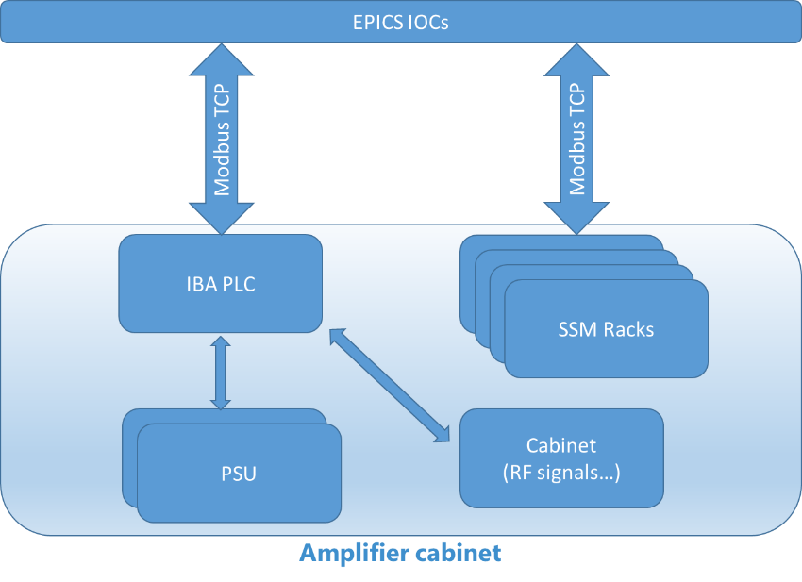
Figure 1 Architecture of the upgraded control system.

As shown in the table below, each cabinets will be configured with a defined quantity of rack and Power Supply Units, according to the required power by each cavity. In order to identify the affiliation of each rack to different amplifiers, an ID table will be provided. Independently of the cabinet configuration, only one PLC per cabinet will be embedded. This means that the affiliations of each data set to different amplifiers will be performed at the EPICS level. Also, the cabinet architecture imposes the sharing of the PSUs, meaning that all PSUs are supplying all racks.
Cabinet | MYRTE | Cab 1 |  |  |  | Cab 2 |  | Cab 3 |  | Cab 4
Amplifiers for cavity | RFQ | QWR1 | QWR2 | CH1 | CH2 | CH5 | CH7 | CH3 | CH4 | CH6
Rack quantity | 32 | 1 | 1 | 4 | 4 | 8 | 8 | 6 | 6 | 10
PSU quantity | 18 | 6 |  |  |  | 9 |  | 6 |  | 6
PLC interface | 1 | 1 |  |  |  | 1 |  | 1 |  | 1

Cabinet | Cab 5 | Cab 6
Amplifiers for | Coupler test | Spoke1 | Spoke 2
Rack quantity | 16 | 4 | 4
PSU quantity | 9 | 5
PLC interface | 1 | 1

Figure 2 below give an example of configuration.
Figure 2 : Example of cabinet configuration

Amplifier local Control System Requirements

IBA SSM RF Cabinets (cavities) |  | Cab 1 (QWR1 + QWR2 + CH1 + CH2) | Cab2 (CH3 + CH4) | Cab 3 (CH5 + CH7) | Cab 4 (CH6)
SPECIFICATIONS | UNITS
General
Communication via |  | IBA PLC and SSM module use Modbus TCP
Command access |  | Through IBA PLC for functional command (on/off/reset)  SSM commands are sent directly from IOC to SSM through raw TCP protocol for buffer and trigger management only
Safety interlocks |  | Push button on the amplifiers, SCK to connect themselves on it to be able to cut the supply and RF (Electrical contacts in serie)
External interlocks |  | Water flow (cabinet, dummy load), emergency off… -> 1 general external interlock per cabinet
Fast external interlock |  | Action on main RF switch analogic; DB9 interface RS485
Internal interlocks |  | fwd and refl power (No limit but threshold for the alarm)
Internal interlocks |  | Voltage and current on each pallet (Alarm when there is a default on the pallet + sanity check at start + continuous current check)
Internal interlocks |  | Voltage/current of each PS
Internal interlocks |  | Input and output temperature of air (rack input and output air temperature - 2 measurements/rack)
Internal interlocks |  | Input and output temperature of water cooling (rack input and output water temperature - 2 measurements/rack)
Fast interlock output type |  | RS485
Monitoring |  | fwd and refl power
Monitoring |  | Voltage and current on each pallet
Monitoring |  | Voltage/current of each PS
Monitoring |  | Input and output temperature of air
Monitoring |  | Input and output temperature of internal water cooling
Monitoring |  | Input and output temperature of external water cooling
Monitoring |  | External flow meter
Monitoring |  | External water flow switches state
External water cooling interface |  | Sockets for temperatures (2 items), flow meter (1 item) and flow switch (2 items)
Local/ Remote Control |  | By software
RF Status |  | OFF, alim ON, RF ON
Flag management |  | Flag latched every 250 ms (refreshment frequency)
Displays on PLC |  | permanent current dispersion curve (difficult to implement since the PLC has no graph/histogram function - not designed for such data analysis)
Logging mode |  | Expert / operator, through password (Operator: Start, Stop, Reset; Expert: + all other settings e.g. thresholds for alarms & calibrations)
Permanent and Slow transfer to EPICS
Global transfer time | s | <= 1s
Transfer mode with racks |  | Modbus TCP (still to be fully tested, first but seems feasible)
Transfer mode with IBA PLC |  | for PSU, cabinet and external coupler data: Ethercat (Modbus preferred because everywhere else in the cabinet)
Transferred value |  | only instantaneous value (mean data, max/min not required)
Frequency transfer for PLC and SSM modules data | ms | IBA PLC data (external coupler, cabinet, all flags): ~ 40 ms  SSM modules data: between 250 ms and 500 ms
Fast acquisition buffering for post or online processing
Data of interest for fast acquisition |  | buffering set only for powers, pallet currents, pallet voltages and flags. NOT for fans, temperatures, integrated currents, voltage references
Embedded buffers | s | 20 sec storage
buffers per rack |  | 2
buffers per IBA PLC |  | not required (Transfer rate (40 ms) equivalent to acquisition rate, so no buffer required)
RF signal sampling speed | ms | 2  Explanatory comment: due to continuous acquisition, uP management tasks (reply to Modbus, measure fan speed & reference…) to be spread during idle time between 2 measurement
Other sampling speed | ms | current/voltage/power/flag: 2 ms
Time stamp to buffered samples |  | only one time stamp every 2ms for current/voltage/power/flag (Error max: +/- 1 ms)
Transfer mode with racks |  | Modbus (still to be fully tested, first but seems feasible)
Buffer loading/unloading protocol
Loading mode |  | Only one of the two buffers (per rack) to be loaded continuously;  When a flag (warning/limit) appears, EPICS sends a “command/trig” to SSM modules (refer to section 3.3.)  (ability to dump and send the data from buffer 1 and to continue recording at the same time on the buffer 2 has to be confirmed)
Unloading protocol |  | The amplifier will switch to the other buffer and EPICS organizes the data transferred of the frozen buffer

Remote Control System Requirements

Architecture overview
This control system is based on the MYRTE development for amplifiers. A lot of these developments are used again in this upgrade.
As shown in the Figure 2, the architecture of the control system with amplifiers is managed by a set of Control Boxes and sub-systems.
Figure 3 Control System Architecture
This architecture is mainly divided into three parts :
- Controls Boxes connected to channel access, to IBA PLCs and to SSMs racks.
- IBA PLCs connected to Controls boxes.
- SSMs racks connected to Controls boxes.

Each of these components uses the following communication protocols :
- Control Boxes use TCP/IP connections.
- IBA PLC use ETHERCAT protocol with Control Boxes.
- SSM racks use MODBUS TCP/IP protocol with Control Boxes.

Control Boxes, typically PCs under Linux Centos, host EPICS IOCs. These IOCs make the link between EPICS channel access and sub-systems.
N IOCs manage the communication with IBA PLCs.
N IOCs manage the communication with SSMs racks.
Detailed topology will be defined by SCK-CEN. Cosylab will develop the EPICS application to be independent of topology, as separate soft IOCs.
The structure of the amplifiers can have many forms (see below Figure 3)
- SSM racks can be grouped to form up to 4 amplifiers in the same cabinet.
- Two cabinets can form one amplifier (MYRTE example).

Figure 4 Amplifier configuration structure.
The data acquisitions send to the control system are of two types:
- Slow monitoring : Typically, the polling process.
- Fast acquisition buffering : For post or online processing.

Amplifier monitoring and control

General requirements
These functions are used to monitor and control the amplifiers at operator level.
Continuous monitoring of the amplifiers is performed with:
- IBA PLC polling.
- SSM racks polling.
See Figure 2 Control System Architecture
All commands from the control systems to drive the amplifier are sent via the IBA controller
The general requirements are the followings :
Transfer protocol with SSMs racks | Modbus TCP
Transfer protocol between IBA PLC & S7 PLC | Ethercat
Transferred data | only instantaneous value
Frequency transfer for PLC and SSM racks data | PLC data ~ 40 ms.  SSM data < 250 to 500 ms.

In the monitoring process,
- one IBA PLC is interrogated by one IOC.
- one IOC can handle several IBA PLCs.

Amplifier commands.

The commands used to drive the amplifier are mainly of types:
- Power supply request.
- Amplifier requests.
- RF request.
- SSM request
To execute a request, the control system of the amplifier must see a transition from 0 to 1 on this request.
Example, to start only the PSU1, we must :
- Set 0 on bit 1 of PSU ON request write value 0 on command register 1.
- Set 1 on bit 1 of PSU ON request write value 2 on command register 1
A "keep alive" command is used by the amplifier to know if the connection with the control system is still valid. This "keep alive" must change at least once a second.
The table below shows all commands used to control an amplifier.
 | Num | Description | type | length  (byte) | Address | Source
POWER SUPPLY | 1 | Power supply ON request | uint16 | 2 | 0 | ( transition from 0 to 1)  bit 0 : All PSU  bit 1 : PSU 1  bit 2 : PSU2  …  bit 9 : PSU 9  …  bit 10 : not used  …  bit 15 : not used
POWER SUPPLY | 2 | Power supply OFF request | uint16 | 2 | 2 | ( transition from 0 to 1)  bit 0 : All PSU  bit 1 : PSU 1  bit 2 : PSU2  …  bit 9 : PSU 9  …  bit 10 : not used  …  bit 15 : not used
AMPLIFIERS | 3 | Amplifier ON and OFF request | byte | 1 | 4 | ( transition from 0 to 1)  bit 0 : Amplifier A on request  bit 1 : Amplifier B on request  bit 2 : Amplifier C on request  bit 3 : Amplifier D on request  bit 4 : Amplifier A off request  bit 5 : Amplifier B off request  bit 6 : Amplifier C off request  bit 7 : Amplifier D off request
AMPLIFIERS | 4 | RF ON and OFF request | byte | 1 | 5 | ( transition from 0 to 1)  bit 0 : Amplifier A RF on request  bit 1 : Amplifier B RF on request  bit 2 : Amplifier C RF on request  bit 3 : Amplifier D RF on request  bit 4 : Amplifier A RF off request  bit 5 : Amplifier B RF off request  bit 6 : Amplifier C RF off request  bit 7 : Amplifier D RF off request
AMPLIFIERS | 5 | SSM 1 ON request | byte | 1 | 6 | ( transition from 0 to 1)  bit 0 : All pallet ON request  bit 1 : Pallet 1 ON request  bit 2 : Pallet 2 ON request  bit 3 : Pallet 3 ON request  bit 4 : Pallet 4 ON request  bit 5 : Pallet 5 ON request  bit 6 : Pallet 6 ON request  bit 7 : not used
AMPLIFIERS | 6 | SSM 2 ON request | byte | 1 | 7 | same as SSM1 ON request
AMPLIFIERS | 7 | SSM 3 ON request | byte | 1 | 8 | same as SSM1 ON request
AMPLIFIERS | 8 | SSM 4 ON request | byte | 1 | 9 | same as SSM1 ON request
AMPLIFIERS | 9 | SSM 5 ON request | byte | 1 | 10 | same as SSM1 ON request
AMPLIFIERS | 10 | SSM 6 ON request | byte | 1 | 11 | same as SSM1 ON request
AMPLIFIERS | 11 | SSM 7 ON request | byte | 1 | 12 | same as SSM1 ON request
AMPLIFIERS | 12 | SSM 8 ON request | byte | 1 | 13 | same as SSM1 ON request
AMPLIFIERS | 13 | SSM 9 ON request | byte | 1 | 14 | same as SSM1 ON request
AMPLIFIERS | 14 | SSM 10 ON request | byte | 1 | 15 | same as SSM1 ON request
AMPLIFIERS | 15 | SSM 11 ON request | byte | 1 | 16 | same as SSM1 ON request
AMPLIFIERS | 16 | SSM 12 ON request | byte | 1 | 17 | same as SSM1 ON request
AMPLIFIERS | 17 | SSM 13 ON request | byte | 1 | 18 | same as SSM1 ON request
AMPLIFIERS | 18 | SSM 14 ON request | byte | 1 | 19 | same as SSM1 ON request
AMPLIFIERS | 19 | SSM 15 ON request | byte | 1 | 20 | same as SSM1 ON request
AMPLIFIERS | 20 | SSM 16 ON request | byte | 1 | 21 | same as SSM1 ON request
AMPLIFIERS | 21 | SSM 1 off request | byte | 1 | 22 | ( transitioff from 0 to 1)  bit 0 : All pallet off request  bit 1 : Pallet 1 off request  bit 2 : Pallet 2 off request  bit 3 : Pallet 3 off request  bit 4 : Pallet 4 off request  bit 5 : Pallet 5 off request  bit 6 : Pallet 6 off request  bit 7 : not used
AMPLIFIERS | 22 | SSM 2 off request | byte | 1 | 23 | same as SSM1 off request
AMPLIFIERS | 23 | SSM 3 off request | byte | 1 | 24 | same as SSM1 off request
AMPLIFIERS | 24 | SSM 4 off request | byte | 1 | 25 | same as SSM1 off request
AMPLIFIERS | 25 | SSM 5 off request | byte | 1 | 26 | same as SSM1 off request
AMPLIFIERS | 26 | SSM 6 off request | byte | 1 | 27 | same as SSM1 off request
AMPLIFIERS | 27 | SSM 7 off request | byte | 1 | 28 | same as SSM1 off request
AMPLIFIERS | 28 | SSM 8 off request | byte | 1 | 29 | same as SSM1 off request
AMPLIFIERS | 29 | SSM 9 off request | byte | 1 | 30 | same as SSM1 off request
AMPLIFIERS | 30 | SSM 10 off request | byte | 1 | 31 | same as SSM1 off request
AMPLIFIERS | 31 | SSM 11 off request | byte | 1 | 32 | same as SSM1 off request
AMPLIFIERS | 32 | SSM 12 off request | byte | 1 | 33 | same as SSM1 off request
AMPLIFIERS | 33 | SSM 13 off request | byte | 1 | 34 | same as SSM1 off request
AMPLIFIERS | 34 | SSM 14 off request | byte | 1 | 35 | same as SSM1 off request
AMPLIFIERS | 35 | SSM 15 off request | byte | 1 | 36 | same as SSM1 off request
AMPLIFIERS | 36 | SSM 16 off request | byte | 1 | 37 | same as SSM1 off request
AMPLIFIERS | 37 | SSM 1 reset request | byte | 1 | 38 | ( transitireset from 0 to 1)  bit 0 : General reset request  bit 1 : Pallet 1 reset request  bit 2 : Pallet 2 reset request  bit 3 : Pallet 3 reset request  bit 4 : Pallet 4 reset request  bit 5 : Pallet 5 reset request  bit 6 : Pallet 6 reset request  bit 7 : not used
AMPLIFIERS | 38 | SSM 2 reset request | byte | 1 | 39 | same as SSM1 reset request
AMPLIFIERS | 39 | SSM 3 reset request | byte | 1 | 40 | same as SSM1 reset request
AMPLIFIERS | 40 | SSM 4 reset request | byte | 1 | 41 | same as SSM1 reset request
AMPLIFIERS | 41 | SSM 5 reset request | byte | 1 | 42 | same as SSM1 reset request
AMPLIFIERS | 42 | SSM 6 reset request | byte | 1 | 43 | same as SSM1 reset request
AMPLIFIERS | 43 | SSM 7 reset request | byte | 1 | 44 | same as SSM1 reset request
AMPLIFIERS | 44 | SSM 8 reset request | byte | 1 | 45 | same as SSM1 reset request
AMPLIFIERS | 45 | SSM 9 reset request | byte | 1 | 46 | same as SSM1 reset request
AMPLIFIERS | 46 | SSM 10 reset request | byte | 1 | 47 | same as SSM1 reset request
AMPLIFIERS | 47 | SSM 11 reset request | byte | 1 | 48 | same as SSM1 reset request
AMPLIFIERS | 48 | SSM 12 reset request | byte | 1 | 49 | same as SSM1 reset request
AMPLIFIERS | 49 | SSM 13 reset request | byte | 1 | 50 | same as SSM1 reset request
AMPLIFIERS | 50 | SSM 14 reset request | byte | 1 | 51 | same as SSM1 reset request
AMPLIFIERS | 51 | SSM 15 reset request | byte | 1 | 52 | same as SSM1 reset request
AMPLIFIERS | 52 | SSM 16 reset request | byte | 1 | 53 | same as SSM1 reset request
AMPLIFIERS | 53 | SSM sanity request | uint16 | 2 | 54 | ( transition from 0 to 1)  bit 0 : SSM 1 sanity request  bit 1 : SSM 2 sanity request  …  bit 15 : SSM 16 sanity request
AMPLIFIERS | 54 | SSM flow request | uint16 | 2 | 56 | ( transition from 0 to 1)  bit 0 : SSM 1 flow request  bit 1 : SSM 2 flow request  …  bit 15 : SSM 16 flow request
GENERAL | 55 | Keep alive | uint16 | 2 | 58 | this register has to be changed within 1s

Polling with the IBA PLC

The Ethercat protocol is to communicate with IBA PLC.

The polling cycle used by a Ethercat data frame mainly consists of the following information (see Figure 4) :
- PSUs states
- Power detectors states
- Water temperatures and flows states
- Lives counters
- ….
Figure 5 Ethercat data frame structure
This frame gives data for one cabinet.
The polling frame structure of the IBA controller has the following format :

 | Num | Description | type | length | Address | Comment
 |  |  |  | (byte) | (byte)
GENERAL | 1 | General status 1 | byte | 1 | 0 | bit 0 : Emergency button  bit 1 : External interlock 1  bit 2 : External interlock 2  bit 3 : Water flow in range  bit 4 : Water flow OK  bit 5 : Leak detection OK  bit 6 : Front door closed  bit 7 : Rear door closed
GENERAL | 2 | General status 2 | byte | 1 | 1 | bit 0 : Local control enable  bit 1 : RF line temperature OK  bit 2 : External temperature 1 warning (1=ok)  bit 3 : External temperature 2 warning (1=ok)  bit 4 : Internal temperature warning (1=ok)  bit 5 : External temperature 1 error (1=ok)  bit 6 : External temperature 2 error (1=ok)  bit 7 : Internal temperature error (1=ok)
GENERAL | 3 | Fan roof pwm setpoint | uint16 | 2 | 2 | in 0.01%
GENERAL | 4 | Fan roof speed | uint16 | 2 | 4 | in rpm
GENERAL | 5 | Fan left pwm setpoint | uint16 | 2 | 6 | in 0.01%
GENERAL | 6 | Fan left 1 speed | uint16 | 2 | 8 | in rpm
GENERAL | 7 | Fan left 2 speed | uint16 | 2 | 10 | in rpm
GENERAL | 8 | Fan right pwm setpoint | uint16 | 2 | 12 | in 0.01%
GENERAL | 9 | Fan right 1 speed | uint16 | 2 | 14 | in rpm
GENERAL | 10 | Fan right 2 speed | uint16 | 2 | 16 | in rpm
GENERAL | 11 | Internal temperature | uint16 | 2 | 18 | in 0.01 deg C
GENERAL | 12 | External temperature 1 | uint16 | 2 | 20 | in 0.01 deg C
GENERAL | 13 | External temperature 2 | uint16 | 2 | 22 | in 0.01 deg C
GENERAL | 14 | Water flow | uint16 | 2 | 24 | in 0.01 L/min
GENERAL | 15 | Live counter | uint16 | 2 | 26
AMPLIFIERS | 16 | Amplifier A status | byte | 1 | 28 | bit 0 : com of all module ok  bit1 : all pallet running  bit 2 : some pallet running  bit 3 : V PSU > 90% set point  bit 4 : RF driver PSU OK  bit 5 : RF driver ON
AMPLIFIERS | 17 | Amplifier A number of pallet running | byte | 1 | 29
AMPLIFIERS | 18 | Amplifier A alarm on module | uint16 | 2 | 30
AMPLIFIERS | 19 | Amplifier A warning on module | uint16 | 2 | 32
AMPLIFIERS | 20 | Amplifier A fwd output power | uint32 | 4 | 34
AMPLIFIERS | 21 | Amplifier A rfl output power | uint32 | 4 | 38
AMPLIFIERS | 22 | Amplifier A VSWR | uint16 | 2 | 42
AMPLIFIERS | 23 | Amplifier A efficiency | uint16 | 2 | 44
AMPLIFIERS | 24 | Amplifier B status | byte | 1 | 46 | bit 0 : com of all module ok  bit1 : all pallet running  bit 2 : some pallet running  bit 3 : V PSU > 90% set point  bit 4 : RF driver PSU OK  bit 5 : RF driver ON
AMPLIFIERS | 25 | Amplifier B number of pallet running | byte | 1 | 47
AMPLIFIERS | 26 | Amplifier B alarm on module | byte | 1 | 48 | Size of regsiter is different from Amp A
AMPLIFIERS | 27 | Amplifier B warning on module | byte | 1 | 49 | Size of regsiter is different from Amp A
AMPLIFIERS | 28 | Amplifier B fwd output power | uint16 | 2 | 50 | Size of regsiter is different from Amp A
AMPLIFIERS | 29 | Amplifier B rfl output power | uint16 | 2 | 52 | Size of regsiter is different from Amp A
AMPLIFIERS | 30 | Amplifier B VSWR | uint16 | 2 | 54
AMPLIFIERS | 31 | Amplifier B efficiency | uint16 | 2 | 56
AMPLIFIERS | 32 | Amplifier C status | byte | 1 | 58 | bit 0 : com of all module ok  bit1 : all pallet running  bit 2 : some pallet running  bit 3 : V PSU > 90% set point  bit 4 : RF driver PSU OK  bit 5 : RF driver ON
AMPLIFIERS | 33 | Amplifier C number of pallet running | byte | 1 | 59
AMPLIFIERS | 34 | Amplifier C alarm on module | byte | 1 | 60 | Size of regsiter is different from Amp A
AMPLIFIERS | 35 | Amplifier C warning on module | byte | 1 | 61 | Size of regsiter is different from Amp A
AMPLIFIERS | 36 | Amplifier C fwd output power | uint16 | 2 | 62 | Size of regsiter is different from Amp A
AMPLIFIERS | 37 | Amplifier C rfl output power | uint16 | 2 | 64 | Size of regsiter is different from Amp A
AMPLIFIERS | 38 | Amplifier C VSWR | uint16 | 2 | 66
AMPLIFIERS | 39 | Amplifier C efficiency | uint16 | 2 | 68
AMPLIFIERS | 40 | Amplifier D status | byte | 1 | 70 | bit 0 : com of all module ok  bit1 : all pallet running  bit 2 : some pallet running  bit 3 : V PSU > 90% set point  bit 4 : RF driver PSU OK  bit 5 : RF driver ON
AMPLIFIERS | 41 | Amplifier D number of pallet running | byte | 1 | 71
AMPLIFIERS | 42 | Amplifier D alarm on module | byte | 1 | 72 | Size of regsiter is different from Amp A
AMPLIFIERS | 43 | Amplifier D warning on module | byte | 1 | 73 | Size of regsiter is different from Amp A
AMPLIFIERS | 44 | Amplifier D fwd output power | uint16 | 2 | 74 | Size of regsiter is different from Amp A
AMPLIFIERS | 45 | Amplifier D rfl output power | uint16 | 2 | 76 | Size of regsiter is different from Amp A
AMPLIFIERS | 46 | Amplifier D VSWR | uint16 | 2 | 78
AMPLIFIERS | 47 | Amplifier D efficiency | uint16 | 2 | 80
POWER SUPPLY | 48 | PSU 1 module 1 voltage | uint16 | 2 | 82 | in mV
POWER SUPPLY | 49 | PSU 1 module 1 current | uint16 | 2 | 84 | in 10 mA
POWER SUPPLY | 50 | PSU 1 module 1 temperature | byte | 1 | 86 | in deg C
POWER SUPPLY | 51 | PSU 1 module 1 status | byte | 1 | 87 | -
POWER SUPPLY | 52 | PSU 1 module 2 voltage | uint16 | 2 | 88 | in mV
POWER SUPPLY | 53 | PSU 1 module 2 current | uint16 | 2 | 90 | in 10 mA
POWER SUPPLY | 54 | PSU 1 module 2 temperature | byte | 1 | 92 | in deg C
POWER SUPPLY | 55 | PSU 1 module 2 status | byte | 1 | 93 | -
POWER SUPPLY | 56 | PSU 1 module 3 voltage | uint16 | 2 | 94 | in mV
POWER SUPPLY | 57 | PSU 1 module 3 current | uint16 | 2 | 96 | in 10 mA
POWER SUPPLY | 58 | PSU 1 module 3 temperature | byte | 1 | 98 | in deg C
POWER SUPPLY | 59 | PSU 1 module 3 status | byte | 1 | 99 | -
POWER SUPPLY | 60 | PSU 2 module 1 voltage | uint16 | 2 | 100 | in mV
POWER SUPPLY | 61 | PSU 2 module 1 current | uint16 | 2 | 102 | in 10 mA
POWER SUPPLY | 62 | PSU 2 module 1 temperature | byte | 1 | 104 | in deg C
POWER SUPPLY | 63 | PSU 2 module 1 status | byte | 1 | 105 | -
POWER SUPPLY | 64 | PSU 2 module 2 voltage | uint16 | 2 | 106 | in mV
POWER SUPPLY | 65 | PSU 2 module 2 current | uint16 | 2 | 108 | in 10 mA
POWER SUPPLY | 66 | PSU 2 module 2 temperature | byte | 1 | 110 | in deg C
POWER SUPPLY | 67 | PSU 2 module 2 status | byte | 1 | 111 | -
POWER SUPPLY | 68 | PSU 2 module 3 voltage | uint16 | 2 | 112 | in mV
POWER SUPPLY | 69 | PSU 2 module 3 current | uint16 | 2 | 114 | in 10 mA
POWER SUPPLY | 70 | PSU 2 module 3 temperature | byte | 1 | 116 | in deg C
POWER SUPPLY | 71 | PSU 2 module 3 status | byte | 1 | 117 | -
POWER SUPPLY | 72 | PSU 3 module 1 voltage | uint16 | 2 | 118 | in mV
POWER SUPPLY | 73 | PSU 3 module 1 current | uint16 | 2 | 120 | in 10 mA
POWER SUPPLY | 74 | PSU 3 module 1 temperature | byte | 1 | 122 | in deg C
POWER SUPPLY | 75 | PSU 3 module 1 status | byte | 1 | 123 | -
POWER SUPPLY | 76 | PSU 3 module 2 voltage | uint16 | 2 | 124 | in mV
POWER SUPPLY | 77 | PSU 3 module 2 current | uint16 | 2 | 126 | in 10 mA
POWER SUPPLY | 78 | PSU 3 module 2 temperature | byte | 1 | 128 | in deg C
POWER SUPPLY | 79 | PSU 3 module 2 status | byte | 1 | 129 | -
POWER SUPPLY | 80 | PSU 3 module 3 voltage | uint16 | 2 | 130 | in mV
POWER SUPPLY | 81 | PSU 3 module 3 current | uint16 | 2 | 132 | in 10 mA
POWER SUPPLY | 82 | PSU 3 module 3 temperature | byte | 1 | 134 | in deg C
POWER SUPPLY | 83 | PSU 3 module 3 status | byte | 1 | 135 | -
POWER SUPPLY | 84 | PSU 4 module 1 voltage | uint16 | 2 | 136 | in mV
POWER SUPPLY | 85 | PSU 4 module 1 current | uint16 | 2 | 138 | in 10 mA
POWER SUPPLY | 86 | PSU 4 module 1 temperature | byte | 1 | 140 | in deg C
POWER SUPPLY | 87 | PSU 4 module 1 status | byte | 1 | 141 | -
POWER SUPPLY | 88 | PSU 4 module 2 voltage | uint16 | 2 | 142 | in mV
POWER SUPPLY | 89 | PSU 4 module 2 current | uint16 | 2 | 144 | in 10 mA
POWER SUPPLY | 90 | PSU 4 module 2 temperature | byte | 1 | 146 | in deg C
POWER SUPPLY | 91 | PSU 4 module 2 status | byte | 1 | 147 | -
POWER SUPPLY | 92 | PSU 4 module 3 voltage | uint16 | 2 | 148 | in mV
POWER SUPPLY | 93 | PSU 4 module 3 current | uint16 | 2 | 150 | in 10 mA
POWER SUPPLY | 94 | PSU 4 module 3 temperature | byte | 1 | 152 | in deg C
POWER SUPPLY | 95 | PSU 4 module 3 status | byte | 1 | 153 | -
POWER SUPPLY | 96 | PSU 5 module 1 voltage | uint16 | 2 | 154 | in mV
POWER SUPPLY | 97 | PSU 5 module 1 current | uint16 | 2 | 156 | in 10 mA
POWER SUPPLY | 98 | PSU 5 module 1 temperature | byte | 1 | 158 | in deg C
POWER SUPPLY | 99 | PSU 5 module 1 status | byte | 1 | 159 | -
POWER SUPPLY | 100 | PSU 5 module 2 voltage | uint16 | 2 | 160 | in mV
POWER SUPPLY | 101 | PSU 5 module 2 current | uint16 | 2 | 162 | in 10 mA
POWER SUPPLY | 102 | PSU 5 module 2 temperature | byte | 1 | 164 | in deg C
POWER SUPPLY | 103 | PSU 5 module 2 status | byte | 1 | 165 | -
POWER SUPPLY | 104 | PSU 5 module 3 voltage | uint16 | 2 | 166 | in mV
POWER SUPPLY | 105 | PSU 5 module 3 current | uint16 | 2 | 168 | in 10 mA
POWER SUPPLY | 106 | PSU 5 module 3 temperature | byte | 1 | 170 | in deg C
POWER SUPPLY | 107 | PSU 5 module 3 status | byte | 1 | 171 | -
POWER SUPPLY | 108 | PSU 6 module 1 voltage | uint16 | 2 | 172 | in mV
POWER SUPPLY | 109 | PSU 6 module 1 current | uint16 | 2 | 174 | in 10 mA
POWER SUPPLY | 110 | PSU 6 module 1 temperature | byte | 1 | 176 | in deg C
POWER SUPPLY | 111 | PSU 6 module 1 status | byte | 1 | 177 | -
POWER SUPPLY | 112 | PSU 6 module 2 voltage | uint16 | 2 | 178 | in mV
POWER SUPPLY | 113 | PSU 6 module 2 current | uint16 | 2 | 180 | in 10 mA
POWER SUPPLY | 114 | PSU 6 module 2 temperature | byte | 1 | 182 | in deg C
POWER SUPPLY | 115 | PSU 6 module 2 status | byte | 1 | 183 | -
POWER SUPPLY | 116 | PSU 6 module 3 voltage | uint16 | 2 | 184 | in mV
POWER SUPPLY | 117 | PSU 6 module 3 current | uint16 | 2 | 186 | in 10 mA
POWER SUPPLY | 118 | PSU 6 module 3 temperature | byte | 1 | 188 | in deg C
POWER SUPPLY | 119 | PSU 6 module 3 status | byte | 1 | 189 | -
POWER SUPPLY | 120 | PSU 7 module 1 voltage | uint16 | 2 | 190 | in mV
POWER SUPPLY | 121 | PSU 7 module 1 current | uint16 | 2 | 192 | in 10 mA
POWER SUPPLY | 122 | PSU 7 module 1 temperature | byte | 1 | 194 | in deg C
POWER SUPPLY | 123 | PSU 7 module 1 status | byte | 1 | 195 | -
POWER SUPPLY | 124 | PSU 7 module 2 voltage | uint16 | 2 | 196 | in mV
POWER SUPPLY | 125 | PSU 7 module 2 current | uint16 | 2 | 198 | in 10 mA
POWER SUPPLY | 126 | PSU 7 module 2 temperature | byte | 1 | 200 | in deg C
POWER SUPPLY | 127 | PSU 7 module 2 status | byte | 1 | 201 | -
POWER SUPPLY | 128 | PSU 7 module 3 voltage | uint16 | 2 | 202 | in mV
POWER SUPPLY | 129 | PSU 7 module 3 current | uint16 | 2 | 204 | in 10 mA
POWER SUPPLY | 130 | PSU 7 module 3 temperature | byte | 1 | 206 | in deg C
POWER SUPPLY | 131 | PSU 7 module 3 status | byte | 1 | 207 | -
POWER SUPPLY | 132 | PSU 8 module 1 voltage | uint16 | 2 | 208 | in mV
POWER SUPPLY | 133 | PSU 8 module 1 current | uint16 | 2 | 210 | in 10 mA
POWER SUPPLY | 134 | PSU 8 module 1 temperature | byte | 1 | 212 | in deg C
POWER SUPPLY | 135 | PSU 8 module 1 status | byte | 1 | 213 | -
POWER SUPPLY | 136 | PSU 8 module 2 voltage | uint16 | 2 | 214 | in mV
POWER SUPPLY | 137 | PSU 8 module 2 current | uint16t | 2 | 216 | in 10 mA
POWER SUPPLY | 138 | PSU 8 module 2 temperature | byte | 1 | 218 | in deg C
POWER SUPPLY | 139 | PSU 8 module 2 status | byte | 1 | 219 | -
POWER SUPPLY | 140 | PSU 8 module 3 voltage | uint16 | 2 | 220 | in mV
POWER SUPPLY | 141 | PSU 8 module 3 current | uint16 | 2 | 222 | in 10 mA
POWER SUPPLY | 142 | PSU 8 module 3 temperature | byte | 1 | 224 | in deg C
POWER SUPPLY | 143 | PSU 8 module 3 status | byte | 1 | 225 | -
POWER SUPPLY | 144 | PSU 9 module 1 voltage | uint16 | 2 | 226 | in mV
POWER SUPPLY | 145 | PSU 9 module 1 current | uint16 | 2 | 228 | in 10 mA
POWER SUPPLY | 146 | PSU 9 module 1 temperature | byte | 1 | 230 | in deg C
POWER SUPPLY | 147 | PSU 9 module 1 status | byte | 1 | 231 | -
POWER SUPPLY | 148 | PSU 9 module 2 voltage | uint16 | 2 | 232 | in mV
POWER SUPPLY | 149 | PSU 9 module 2 current | uint16 | 2 | 234 | in 10 mA
POWER SUPPLY | 150 | PSU 9 module 2 temperature | byte | 1 | 236 | in deg C
POWER SUPPLY | 151 | PSU 9 module 2 status | byte | 1 | 237 | -
POWER SUPPLY | 152 | PSU 9 module 3 voltage | uint16 | 2 | 238 | in mV
POWER SUPPLY | 153 | PSU 9 module 3 current | uint16 | 2 | 240 | in 10 mA
POWER SUPPLY | 154 | PSU 9 module 3 temperature | byte | 1 | 242 | in deg C
POWER SUPPLY | 155 | PSU 9 module 3 status | byte | 1 | 243 | -
Table 1 IBA PLC frame polling table structure.
Depending on the amplifier‘s configuration (1 or 2 cabinets), one or two frames are needed to get all polling information’s.
Unused data blocks are set to zero.
For example, if a cabinet contains 2 amplifiers, only the pooling data for amplifiers A and B are completed. The data for the amplifiers C and D are set to zero.

Polling with SSM racks

The protocol used between SSMs racks and EPICS IOCs on Controls Boxes is MODBUS TCP.
MODBUS input registers for the polling process start at address 1000₁₀.
The polling cycle is divided in multiple MODBUS data frames :
- Data that never changes except in case of software update (white in table below).
- Main data frame that can be put in one MODBUS frame (green in table below).
- Additional data which doesn't fit in one Modbus frame but can be re-computed from the main data frame (blue in the end of table below).
See details in table below:
 |  | num | Name | Unit | Type | length | Address
 |  |  |  |  |  | (word) | dec | hexa
DATA THAT NEVER CHANGE (exept after a soft update) |  | 1 | SSM address |  | uint16_t | 1 | 0 | 0x0000
 |  | 2 | Serial Number |  | uint16_t | 1 | 1 | 0x0001
 |  | 3 | Hardware version |  | uint16_t | 1 | 2 | 0x0002
 |  | 4 | Software version |  | uint16_t | 1 | 3 | 0x0003
MAIN DATA THAT CAN BE PUT IN ONLY ONE MUDBUS FRAME |  | 5 | Live counter |  | uint16_t | 1 | 4 | 0x0004
MAIN DATA THAT CAN BE PUT IN ONLY ONE MUDBUS FRAME | Status | 6 | SSM status |  | uint16_t | 1 | 5 | 0x0005
MAIN DATA THAT CAN BE PUT IN ONLY ONE MUDBUS FRAME | Status | 7 | Pallet status |  | uint16_t | 1 | 6 | 0x0006
MAIN DATA THAT CAN BE PUT IN ONLY ONE MUDBUS FRAME | Status | 8 | Reset status |  | uint16_t | 1 | 7 | 0x0007
MAIN DATA THAT CAN BE PUT IN ONLY ONE MUDBUS FRAME | Status | 9 | Power status |  | uint16_t | 1 | 8 | 0x0008
MAIN DATA THAT CAN BE PUT IN ONLY ONE MUDBUS FRAME | Status | 10 | Voltage limit status |  | uint16_t | 1 | 9 | 0x0009
MAIN DATA THAT CAN BE PUT IN ONLY ONE MUDBUS FRAME | Status | 11 | Current limit status |  | uint16_t | 1 | 10 | 0x000A
MAIN DATA THAT CAN BE PUT IN ONLY ONE MUDBUS FRAME | Status | 12 | Warning temp |  | uint16_t | 1 | 11 | 0x000B
MAIN DATA THAT CAN BE PUT IN ONLY ONE MUDBUS FRAME | Status | 13 | Over temp |  | uint16_t | 1 | 12 | 0x000C
MAIN DATA THAT CAN BE PUT IN ONLY ONE MUDBUS FRAME | Status | 14 | Reference status |  | uint16_t | 1 | 13 | 0x000D
MAIN DATA THAT CAN BE PUT IN ONLY ONE MUDBUS FRAME |  | 15 | P fwd pallet 1 | W | float | 2 | 14 | 0x000E
MAIN DATA THAT CAN BE PUT IN ONLY ONE MUDBUS FRAME |  | 16 | P fwd pallet 2 | W | float | 2 | 16 | 0x0010
MAIN DATA THAT CAN BE PUT IN ONLY ONE MUDBUS FRAME |  | 17 | P fwd pallet 3 | W | float | 2 | 18 | 0x0012
MAIN DATA THAT CAN BE PUT IN ONLY ONE MUDBUS FRAME |  | 18 | P fwd pallet 4 | W | float | 2 | 20 | 0x0014
MAIN DATA THAT CAN BE PUT IN ONLY ONE MUDBUS FRAME |  | 19 | P fwd pallet 5 | W | float | 2 | 22 | 0x0016
MAIN DATA THAT CAN BE PUT IN ONLY ONE MUDBUS FRAME |  | 20 | P fwd pallet 6 | W | float | 2 | 24 | 0x0018
MAIN DATA THAT CAN BE PUT IN ONLY ONE MUDBUS FRAME |  | 21 | P rfl pallet 1 | W | float | 2 | 26 | 0x001A
MAIN DATA THAT CAN BE PUT IN ONLY ONE MUDBUS FRAME |  | 22 | P rfl pallet 2 | W | float | 2 | 28 | 0x001C
MAIN DATA THAT CAN BE PUT IN ONLY ONE MUDBUS FRAME |  | 23 | P rfl pallet 3 | W | float | 2 | 30 | 0x001E
MAIN DATA THAT CAN BE PUT IN ONLY ONE MUDBUS FRAME |  | 24 | P rfl pallet 4 | W | float | 2 | 32 | 0x0020
MAIN DATA THAT CAN BE PUT IN ONLY ONE MUDBUS FRAME |  | 25 | P rfl pallet 5 | W | float | 2 | 34 | 0x0022
MAIN DATA THAT CAN BE PUT IN ONLY ONE MUDBUS FRAME |  | 26 | P rfl pallet 6 | W | float | 2 | 36 | 0x0024
MAIN DATA THAT CAN BE PUT IN ONLY ONE MUDBUS FRAME |  | 27 | P fwd combiner | W | float | 2 | 38 | 0x0026
MAIN DATA THAT CAN BE PUT IN ONLY ONE MUDBUS FRAME |  | 28 | P rfl combiner | W | float | 2 | 40 | 0x0028
MAIN DATA THAT CAN BE PUT IN ONLY ONE MUDBUS FRAME |  | 29 | P fwd 6 kW load | W | float | 2 | 42 | 0x002A
MAIN DATA THAT CAN BE PUT IN ONLY ONE MUDBUS FRAME |  | 30 | P rfl 6 kW load | W | float | 2 | 44 | 0x002C
MAIN DATA THAT CAN BE PUT IN ONLY ONE MUDBUS FRAME |  | 31 | Current P1 | A | float | 2 | 46 | 0x002E
MAIN DATA THAT CAN BE PUT IN ONLY ONE MUDBUS FRAME |  | 32 | Current P2 | A | float | 2 | 48 | 0x0030
MAIN DATA THAT CAN BE PUT IN ONLY ONE MUDBUS FRAME |  | 33 | Current P3 | A | float | 2 | 50 | 0x0032
MAIN DATA THAT CAN BE PUT IN ONLY ONE MUDBUS FRAME |  | 34 | Current P4 | A | float | 2 | 52 | 0x0034
MAIN DATA THAT CAN BE PUT IN ONLY ONE MUDBUS FRAME |  | 35 | Current P5 | A | float | 2 | 54 | 0x0036
MAIN DATA THAT CAN BE PUT IN ONLY ONE MUDBUS FRAME |  | 36 | Current P6 | A | float | 2 | 56 | 0x0038
MAIN DATA THAT CAN BE PUT IN ONLY ONE MUDBUS FRAME |  | 37 | trip counter P1 |  | uint16_t | 1 | 58 | 0x003A
MAIN DATA THAT CAN BE PUT IN ONLY ONE MUDBUS FRAME |  | 38 | trip counter P2 |  | uint16_t | 1 | 59 | 0x003B
MAIN DATA THAT CAN BE PUT IN ONLY ONE MUDBUS FRAME |  | 39 | trip counter P3 |  | uint16_t | 1 | 60 | 0x003C
MAIN DATA THAT CAN BE PUT IN ONLY ONE MUDBUS FRAME |  | 40 | trip counter P4 |  | uint16_t | 1 | 61 | 0x003D
MAIN DATA THAT CAN BE PUT IN ONLY ONE MUDBUS FRAME |  | 41 | trip counter P5 |  | uint16_t | 1 | 62 | 0x003E
MAIN DATA THAT CAN BE PUT IN ONLY ONE MUDBUS FRAME |  | 42 | trip counter P6 |  | uint16_t | 1 | 63 | 0x003F
MAIN DATA THAT CAN BE PUT IN ONLY ONE MUDBUS FRAME |  | 43 | Voltage P1 | V | float | 2 | 64 | 0x0040
MAIN DATA THAT CAN BE PUT IN ONLY ONE MUDBUS FRAME |  | 44 | Voltage P2 | V | float | 2 | 66 | 0x0042
MAIN DATA THAT CAN BE PUT IN ONLY ONE MUDBUS FRAME |  | 45 | Voltage P3 | V | float | 2 | 68 | 0x0044
MAIN DATA THAT CAN BE PUT IN ONLY ONE MUDBUS FRAME |  | 46 | Voltage P4 | V | float | 2 | 70 | 0x0046
MAIN DATA THAT CAN BE PUT IN ONLY ONE MUDBUS FRAME |  | 47 | Voltage P5 | V | float | 2 | 72 | 0x0048
MAIN DATA THAT CAN BE PUT IN ONLY ONE MUDBUS FRAME |  | 48 | Voltage P6 | V | float | 2 | 74 | 0x004A
MAIN DATA THAT CAN BE PUT IN ONLY ONE MUDBUS FRAME |  | 49 | Water in temperature | deg C | float | 2 | 76 | 0x004C
MAIN DATA THAT CAN BE PUT IN ONLY ONE MUDBUS FRAME |  | 50 | Water out temperature | deg C | float | 2 | 78 | 0x004E
MAIN DATA THAT CAN BE PUT IN ONLY ONE MUDBUS FRAME |  | 51 | Air in temperature | deg C | float | 2 | 80 | 0x0050
MAIN DATA THAT CAN BE PUT IN ONLY ONE MUDBUS FRAME |  | 52 | Air out temperature | deg C | float | 2 | 82 | 0x0052
MAIN DATA THAT CAN BE PUT IN ONLY ONE MUDBUS FRAME |  | 53 | Load temperature 1 | deg C | float | 2 | 84 | 0x0054
MAIN DATA THAT CAN BE PUT IN ONLY ONE MUDBUS FRAME |  | 54 | Load temperature 2 | deg C | float | 2 | 86 | 0x0056
MAIN DATA THAT CAN BE PUT IN ONLY ONE MUDBUS FRAME |  | 55 | IO board temperature | deg C | float | 2 | 88 | 0x0058
MAIN DATA THAT CAN BE PUT IN ONLY ONE MUDBUS FRAME |  | 56 | Temperature ref 10k | deg C | float | 2 | 90 | 0x005A
MAIN DATA THAT CAN BE PUT IN ONLY ONE MUDBUS FRAME |  | 57 | ADC temperature | deg C | float | 2 | 92 | 0x005C
MAIN DATA THAT CAN BE PUT IN ONLY ONE MUDBUS FRAME |  | 58 | uP temperature | deg C | float | 2 | 94 | 0x005E
MAIN DATA THAT CAN BE PUT IN ONLY ONE MUDBUS FRAME |  | 59 | Pallet 1-2 temperature | deg C | float | 2 | 96 | 0x0060
MAIN DATA THAT CAN BE PUT IN ONLY ONE MUDBUS FRAME |  | 60 | Pallet 3-4 temperature | deg C | float | 2 | 98 | 0x0062
MAIN DATA THAT CAN BE PUT IN ONLY ONE MUDBUS FRAME |  | 61 | Pallet 5-6 temperature | deg C | float | 2 | 100 | 0x0064
MAIN DATA THAT CAN BE PUT IN ONLY ONE MUDBUS FRAME |  | 62 | PWM fan x | % | uint16_t | 1 | 102 | 0x0066
MAIN DATA THAT CAN BE PUT IN ONLY ONE MUDBUS FRAME |  | 63 | speed fan 1 | rpm | uint16_t | 1 | 103 | 0x0067
MAIN DATA THAT CAN BE PUT IN ONLY ONE MUDBUS FRAME |  | 64 | speed fan 2 | rpm | uint16_t | 1 | 104 | 0x0068
MAIN DATA THAT CAN BE PUT IN ONLY ONE MUDBUS FRAME |  | 65 | speed fan 3 | rpm | uint16_t | 1 | 105 | 0x0069
MAIN DATA THAT CAN BE PUT IN ONLY ONE MUDBUS FRAME |  | 66 | 50V PSU feedback | V | float | 2 | 106 | 0x006A
MAIN DATA THAT CAN BE PUT IN ONLY ONE MUDBUS FRAME |  | 67 | ADC Voltage reference | V | float | 2 | 108 | 0x006C
MAIN DATA THAT CAN BE PUT IN ONLY ONE MUDBUS FRAME |  | 68 | Junction temperature P1 | W | float | 2 | 110 | 0x006E
MAIN DATA THAT CAN BE PUT IN ONLY ONE MUDBUS FRAME |  | 69 | Junction temperature P2 | W | float | 2 | 112 | 0x0070
MAIN DATA THAT CAN BE PUT IN ONLY ONE MUDBUS FRAME |  | 70 | Junction temperature P3 | W | float | 2 | 114 | 0x0072
MAIN DATA THAT CAN BE PUT IN ONLY ONE MUDBUS FRAME |  | 71 | Junction temperature P4 | W | float | 2 | 116 | 0x0074
MAIN DATA THAT CAN BE PUT IN ONLY ONE MUDBUS FRAME |  | 72 | Junction temperature P5 | W | float | 2 | 118 | 0x0076
MAIN DATA THAT CAN BE PUT IN ONLY ONE MUDBUS FRAME |  | 73 | Junction temperature P6 | W | float | 2 | 120 | 0x0078
 |  | 74 | VSWR pallet 1 |  | float | 2 | 122 | 0x007A
 |  | 75 | VSWR pallet 2 |  | float | 2 | 124 | 0x007C
 |  | 76 | VSWR pallet 3 |  | float | 2 | 126 | 0x007E
 |  | 77 | VSWR pallet 4 |  | float | 2 | 128 | 0x0080
 |  | 78 | VSWR pallet 5 |  | float | 2 | 130 | 0x0082
 |  | 79 | VSWR pallet 6 |  | float | 2 | 132 | 0x0084
 |  | 80 | VSWR combiner |  | float | 2 | 134 | 0x0086
 |  | 81 | VSWR load |  | float | 2 | 136 | 0x0088
 |  | 74 | hardware reset |  | uint16_t | 1 | 138 | 0x008A
 |  | 75 | software reset |  | uint16_t | 1 | 139 | 0x008B
 |  | 76 | watchdog reset |  | uint16_t | 1 | 140 | 0x008C
 |  | 77 | Sanity current open P1 | A | float | 2 | 141 | 0x008D
 |  | 78 | Sanity current open P2 | A | float | 2 | 143 | 0x008F
 |  | 79 | Sanity current open P3 | A | float | 2 | 145 | 0x0091
 |  | 80 | Sanity current open P4 | A | float | 2 | 147 | 0x0093
 |  | 81 | Sanity current open P5 | A | float | 2 | 149 | 0x0095
 |  | 82 | Sanity current open P6 | A | float | 2 | 151 | 0x0097
 |  | 83 | Sanity current close P1 | A | float | 2 | 153 | 0x0099
 |  | 84 | Sanity current close P2 | A | float | 2 | 155 | 0x009B
 |  | 85 | Sanity current close P3 | A | float | 2 | 157 | 0x009D
 |  | 86 | Sanity current close P4 | A | float | 2 | 159 | 0x009F
 |  | 87 | Sanity current close P5 | A | float | 2 | 161 | 0x00A1
 |  | 88 | Sanity current close P6 | A | float | 2 | 163 | 0x00A3
 |  | 89 | Bias P1 | digit | uint16_t | 1 | 165 | 0x00A5
 |  | 90 | Bias P2 | digit | uint16_t | 1 | 166 | 0x00A6
 |  | 91 | Bias P3 | digit | uint16_t | 1 | 167 | 0x00A7
 |  | 92 | Bias P4 | digit | uint16_t | 1 | 168 | 0x00A8
 |  | 93 | Bias P5 | digit | uint16_t | 1 | 169 | 0x00A9
 |  | 94 | Bias P6 | digit | uint16_t | 1 | 170 | 0x00AA
 |  | 95 | Flow rate on request | l/min | float | 2 | 171 | 0x00AB
 |  | 96 | Flow rate | l/min | float | 2 | 173 | 0x00AD
 |  | 97 | Time stamp | s | uint64_t | 4 | 175 | 0x00AF
 |  | 98 | Time stamp ms | ms | uint16_t | 2 | 179 | 0x00B3

Table 2 SSM rack frame polling table structure.
The polling is then divided in step:
- Main data frame (part in green in Table 2) - > fast cycle, polled as quickly as possible
- Additional data frame (part in white and blue in Table 2) -> slow cycle, polled slowly (each 5 minutes for example).

The status information stored in the polling frame (see registers address 5 to 13 in Table 2 ) have the following detailed structure :
 | Bit 0 | Bit 1 | Bit 2 | Bit 3 | Bit 4 | Bit 5 | Bit 6 | Bit 7
SSM status | limit sum | warn sum | com status | mode | x | memory bank use | trigger status | x
Pallet status | ON/OFF P1 | ON/OFF P2 | ON/OFF P3 | ON/OFF P4 | ON/OFF P5 | ON/OFF P6 | x | x
Reset status | need rst P1 | need rst P2 | need rst P3 | need rst P4 | need rst P5 | need rst P6 | x | x
Warning temp | water_in | water_out | air_in | air_out | load 1 | load 2 | io board | ref 10k
Over temp | water_in | water_out | air_in | air_out | load 1 | load 2 | io board | pallet 1-2
Power status | VSWR P1 | VSWR P2 | VSWR P3 | VSWR P4 | VSWR P5 | VSWR P6 | VSWR combiner | VSWR load
Voltage limit status | P1 | P2 | P3 | P4 | P5 | P6 | x | x
Current limit status | P1 | P2 | P3 | P4 | P5 | P6 | x | x
Reference status | PSU | 12 V PSU | v ref | v gnd | adc ref | 12V FAN | x | x

 | Bit 8 | Bit 9 | Bit 10 | Bit 11 | Bit 12 | Bit 13 | Bit 14 | Bit 15
SSM status | x | x | x | x | x | x | x | major issue
Pallet status | Sanity P1 | Sanity P2 | Sanity P3 | Sanity P4 | Sanity P5 | Sanity P6 | x | x
Reset status | need ref rst | x | x | x | x | x | x | x
Warning temp | adc | pallet 1-2 | pallet 3-4 | pallet 5-6 | up | x | x | x
Over temp | adc | pallet 1-2 | pallet 3-4 | pallet 5-6 | up | x | x | x
Power status | P1 Pdis | P2 Pdis | P3 Pdis | P4 Pdis | P5 Pdis | P6 Pdis | warn Pout | limit Pout
Voltage limit status | x | x | x | x | x | x | x | x
Current limit status | x | x | x | x | x | x | x | x
Reference status | fan 1 | fan 2 | fan 3 | fan 1 psu | fan 2 psu | fan 3 psu | fan 4 psu | x
Table 3 SSM detailed status information.
The “x” indicate that bit position is unused.

SSM status register on bit 5 : indicates the memory buffer used for data acquisition (see Fast acquisition buffering section).
- 0: use of buffer 1.
- 1: use of buffer 2.

SSM status register – bit 6 : indicates the trigger status (see Fast acquisition buffering section).
- 0: trigger unarmed.
- 1: trigger armed.

Fast acquisition buffering with SSM racks

General requirements
Fast Acquisition Buffering retrieves all acquisition data that cannot be read quickly enough through a polling process. Based on a trigger system, it allows to download all the post-mortem data of amplifiers for a period of 20 seconds.
The general requirements are the followings :
Data of interest for fast acquisition | buffering set only for powers, pallet currents, pallet voltages and flags.  NOT for fans, temperatures, integrated currents, voltage references
Embedded buffers | 20 sec storage
buffers per SSM rack | 2
Sampling speed | current/voltage/power: 2 ms
Time stamp to buffered samples | only one time stamp every 2ms for current/voltage/power/flag
Data transfer protocol with SSM racks | Raw TCP/IP

The buffering process (see illustration in Figure 5) is based on two circular buffer memories that store up to 20 seconds of data acquisition.
Only one buffer memory is active at a time. The downloadable data to the control system are always those of the inactive buffer.
A trigger is armed by a command sent by the control system and is released by :
- A request from the control system.
- When one or more alarms specified in a configuration mask has occurred.

When the trigger has just been released, all current acquisitions go into the other buffer (see Figure 5 ).
Figure 6 Double buffering principle.

Data structure of one acquisition point.
Each data acquisition stored in circular buffers have the following defined format.

 | Num. | Name |  |  | Unit | type | length
 |  |  |  |  |  |  | byte
 | 1 | Time stamp since 1900 |  |  |  | uint64_t | 8
 | 2 | Time stamp millisecond |  |  |  | uint16_t | 2
STATUS | 3 | SSM status |  |  |  | uint16_t | 2
STATUS | 4 | Pallet status |  |  |  | uint16_t | 2
STATUS | 5 | Reset status |  |  |  | uint16_t | 2
STATUS | 6 | Power status |  |  |  | uint16_t | 2
STATUS | 7 | Voltage limit status |  |  |  | uint16_t | 2
STATUS | 8 | Current limit status |  |  |  | uint16_t | 2
STATUS | 9 | Warning temp |  |  |  | uint16_t | 2
STATUS | 10 | Over temp |  |  |  | uint16_t | 2
STATUS | 11 | Reference status |  |  |  | uint16_t | 2
 | 12 | Power forward pallet 1 |  |  | Watt | float | 4
 | 13 | P fwd pallet 2 |  |  | W | float | 4
 | 14 | P fwd pallet 3 |  |  | W | float | 4
 | 15 | P fwd pallet 4 |  |  | W | float | 4
 | 16 | P fwd pallet 5 |  |  | W | float | 4
 | 17 | P fwd pallet 6 |  |  | W | float | 4
 | 18 | Power reflect pallet 1 |  |  | W | float | 4
 | 19 | P rfl pallet 2 |  |  | W | float | 4
 | 20 | P rfl pallet 3 |  |  | W | float | 4
 | 21 | P rfl pallet 4 |  |  | W | float | 4
 | 22 | P rfl pallet 5 |  |  | W | float | 4
 | 23 | P rfl pallet 6 |  |  | W | float | 4
 | 24 | P fwd combiner |  |  | W | float | 4
 | 25 | P rfl combiner |  |  | W | float | 4
 | 26 | P fwd 6 kW load |  |  | W | float | 4
 | 27 | P rfl 6 kW load |  |  | W | float | 4
 | 28 | Current P1 |  |  | Ampere | float | 4
 | 29 | Current P2 |  |  | A | float | 4
 | 30 | Current P3 |  |  | A | float | 4
 | 31 | Current P4 |  |  | A | float | 4
 | 32 | Current P5 |  |  | A | float | 4
 | 33 | Current P6 |  |  | A | float | 4
 | 34 | Voltage P1 |  |  | V | float | 4
 | 35 | Voltage P2 |  |  | V | float | 4
 | 36 | Voltage P3 |  |  | V | float | 4
 | 37 | Voltage P4 |  |  | V | float | 4
 | 38 | Voltage P5 |  |  | V | float | 4
 | 39 | Voltage P6 |  |  | V | float | 4
Table 4 Data Structure of one acquisition point in buffer on SSM rack.
The size of a data block is 140 bytes.
The total amount of acquisitions over 20 sec is 10000 points (one point every 2 ms).
The size to download a complete buffer is around 1,4 Mbytes per SSM rack.

Masking configuration table

A configuration mask can be associated with a trigger. It setting up on an SSM rack via Raw TCP protocol (see next section).
The mask defines all alarms that will activate the trigger if they appear.
This mask is set before to arm the trigger.
The mask structure, shown below, is identical to the status information sent by the polling:
 | Bit 0 | Bit 1 | Bit 2 | Bit 3 | Bit 4 | Bit 5 | Bit 6 | Bit 7
SSM status | limit sum | warn sum | com status | mode | x | memory bank use | trigger status | x
Pallet status | ON/OFF P1 | ON/OFF P2 | ON/OFF P3 | ON/OFF P4 | ON/OFF P5 | ON/OFF P6 | x | x
Reset status | need rst P1 | need rst P2 | need rst P3 | need rst P4 | need rst P5 | need rst P6 | x | x
Warning temp | water_in | water_out | air_in | air_out | load 1 | load 2 | io board | ref 10k
Over temp | water_in | water_out | air_in | air_out | load 1 | load 2 | io board | ref 10k
Power status | VSWR P1 | VSWR P2 | VSWR P3 | VSWR P4 | VSWR P5 | VSWR P6 | VSWR combiner | VSWR load
Voltage limit status | P1 | P2 | P3 | P4 | P5 | P6 | x | x
Current limit status | P1 | P2 | P3 | P4 | P5 | P6 | x | x
Reference status | PSU | 12 V PSU | v ref | v gnd | adc ref | 12V FAN | x | x

 | Bit 8 | Bit 9 | Bit 10 | Bit 11 | Bit 12 | Bit 13 | Bit 14 | Bit 15
SSM status | x | x | x | x | x | x | x | major issue
Pallet status | Sanity P1 | Sanity P2 | Sanity P3 | Sanity P4 | Sanity P5 | Sanity P6 | x | x
Reset status | need ref reset | x | x | x | x | x | x | x
Warning temp | adc | pallet 1-2 | pallet 3-4 | pallet 5-6 | up | x | x | x
Over temp | adc | pallet 1-2 | pallet 3-4 | pallet 5-6 | up | x | x | x
Power status | P1 Pdis | P2 Pdis | P3 Pdis | P4 Pdis | P5 Pdis | P3 Pdis | warn Pout | limit Pout
Voltage limit status | x | x | x | x | x | x | x | x
Current limit status | x | x | x | x | x | x | x | x
Reference status | fan 1 | fan 2 | fan 3 | fan 1 psu | fan 2 psu | fan 3 psu | x | x
Table 5 SSM detailed mask table.
When the bit is set, it means that if the status of the corresponding position changes, the trigger is changing its state.

Raw TCP protocol.

The dump of a SSM rack is downloaded via a basic raw TCP protocol.
The general behavior of this protocol is the following :
- The EPICS IOC module (or other kind of program) opens a TCP/IP socket on the SSM rack and write a command on this one.
- The rack responds with byte code followed or not by multiple bytes depending on the context.

Available commands are :
- Download the dump from the SSM rack.
- Get trigger status.
- Enable or force the trigger.
- Read/Write the mask configuration.

Download the dump.

The command code send by the IOC to start dump’s download is 0xAA.
The following table show the normal sequence to download the dump from SSM rack.
Sequence number | Commands send to SSM rack | Send direction | Reply from SSM rack | Description
1 | 0xAA
2 |  |  | 0x1A | Start dump accepted.
3 |  |  | 0xDD + 1400 bytes | Frame 1 : 0xDD + 10 blocks of 140 first bytes of the data buffer.
4 |  |  | 0xDD + 1400 bytes | Frame 2 : 0xDD + 10 blocks of 140 next bytes of data buffer.
X |  |  | X times  0xDD + 1400 bytes
1004 |  |  | 0xDD + 1400 bytes | Frame 1000 : Last 0xDD + last 10 blocks of 140 bytes of data buffer.

The reception order of data frames is from the most recent to the oldest. (see figure Figure 6).
Figure 7 : Dump data frame order.
When the data buffer is downloaded to the IOC part, it is sent to the archive system.
If, for any reason, the download fails, the data repatriation starts again from the beginning.
If one dump download is already in progress and IOC send the command 0xAA, the following sequence is apply:
Sequence number | Commands send to SSM rack | Send direction | Reply from SSM rack | Description
1 | 0xAA
2 |  |  | 0x00 | dump already enabled

Get trigger. Status.

The command 0x0E get the trigger status.
The answer of the SSM rack could be triggered state or not triggered sate.
Sequence number | Commands send to SSM rack | Send direction | Reply from SSM rack | Description
1 | 0x0E
2 |  |  | 0x0E | Not triggered

Sequence number | Commands send to SSM rack | Send direction | Reply from SSM rack | Description
1 | 0x0E
2 |  |  | 0x1E | Triggered

Enable or force the trig.

To enable the trigger
Sequence number | Commands send to SSM rack | Send direction | Reply from SSM rack | Description
1 | 0xEE
2 |  |  | 0xEE | Enable trigger

To force manually the trigger.
Sequence number | Commands send to SSM rack | Send direction | Reply from SSM rack | Description
1 | 0xFE
2 |  |  | 0x0E | Force trigger

Read/write the mask configuration.

Read the mask configuration of the SSM rack (see chapter 3.3.3. for description).
Sequence number | Commands send to SSM rack | Send direction | Reply from SSM rack | Description
1 | 0x01
2 |  |  | 0x01 + 20 bytes | Read mask configuration, followed by 20 bytes of the mask

Write the mask configuration to the SSM rack (see chapter 3.3.3 for description)
Sequence number | Commands send to SSM rack | Send direction | Reply from SSM rack | Description
1 | 0x11 + 20 bytes |  |  | Write mask configuration, followed by 20 bytes of the mask
2 |  |  | 0x01 | Mask receive

If the mask is invalid or not enough bytes are received, the SSM rack return an error.
Sequence number | Commands send to SSM rack | Send direction | Reply from SSM rack | Description
1 | 0x11 + 20 bytes |  |  | Write mask configuration, followed by 20 bytes of the mask
2 |  |  | 0x00 | Error not enough bytes received

Fast acquisition buffering with IBA PLC

To be discuss with partners.
For the moment, the data coming from the polling is sent in archive EPICS.

Screen configuration

Type | Requirement
General layout for permanent polling | The general layout shall reproduce the IBA local interface philosophy (circuit representation) and use the same labelling. For example, the MYRTE SSM screenshots are shown below in figure 4.  The new local CS interface, from QWR1 to CH7, may change. New interfaces will be communicated asap.
Permanent polling display | Two graphs per amplifier shall be permanently available, aiming to provide a global view instead of reading many figures, as defined here after:  - Transistor current in y-axis for each pallet name (1 transistor per pallet) in x-axis  - Delta T° in y-axis for each SSM name in x-axis  See examples in figures 5 and 6.  A record function shall be implemented to save at any time a specific curve.
Post-processing settings | A window shall be dedicated to post-processing settings (selection of holding table, buffer length, SSMs to be downloaded, force trigger…).  Detailed interface will be defined once polling protocol will be agreed.
Post-processing analysis | A window shall be dedicated to post-processing analysis, allowing versatile curves display.  Signals from LLRF and beam diagnostics shall be loadable in order to allow cross-analysis with SSM signals (could be done at higher system level).  Analyzed graphs shall be recordable.

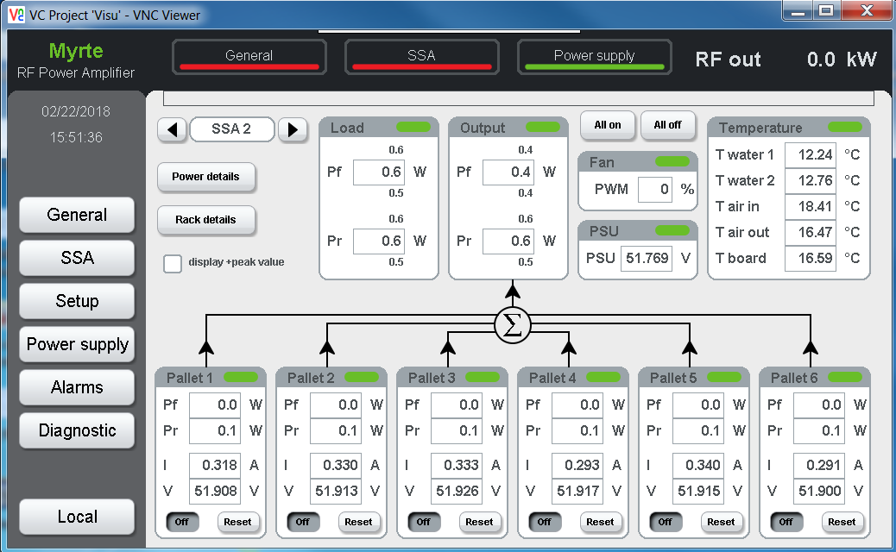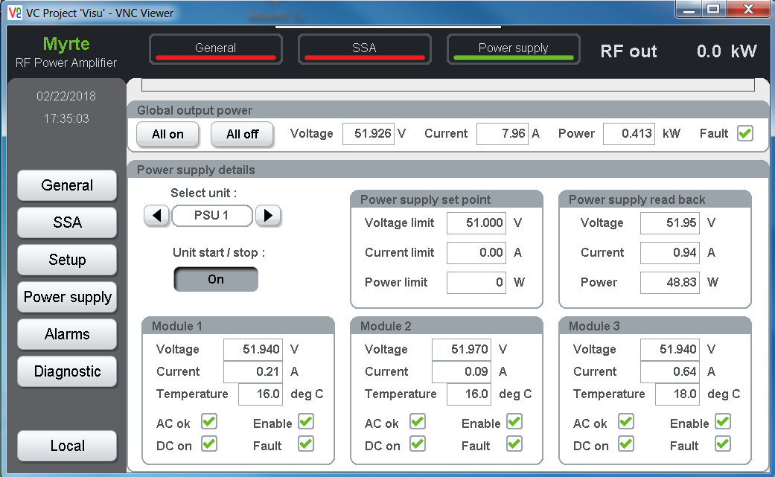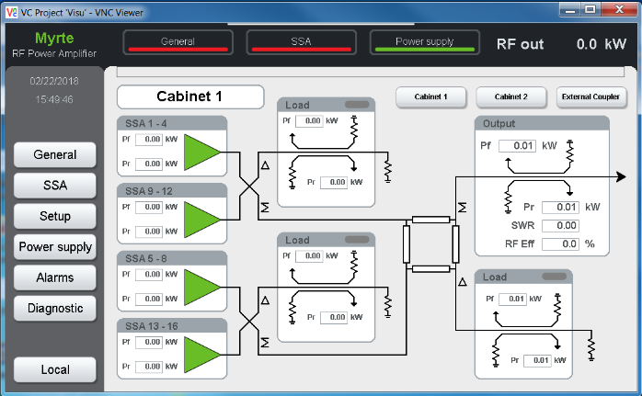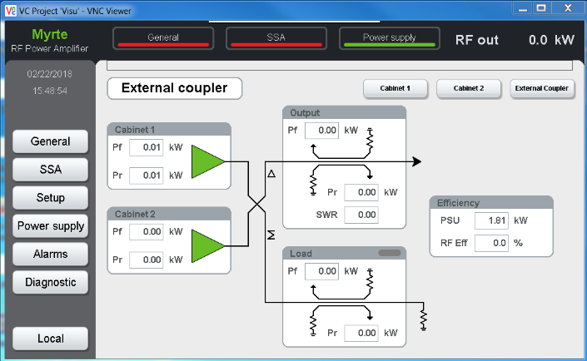
Figure 4 : MYRTE SSM screenshot

Figure 5 : Transistor current for each pallet number

Figure 6 : Delta Temperature for each SSM number

Schedule
In terms of schedule, the current need for the deployment and commissioning of this remote control system is given in the following table. A test protocol will have to be jointly written before the starting of the first commissioning.
Deployment and commissioning | Cab 1 | Cab 2 | Cab 3 | Cab 4 | MYRTE
Starting date | May-19 | Oct-19 | July-19 | Jun-19 | Nov-19

